Cairo University Faculty of Computers and Information



**Software Engineering II**

**Software design specification document**

**2020**

**Project Team**

|  |  |  |  |
| --- | --- | --- | --- |
| **ID** | **Name** | **Email** | **Mobile** |
| **20170043** | **Esraa Taha Ali** | **esraaselim39@gmail.com** | **01102790226** |
| **20170044** | **Esraa Mohamed Abdelrhman** | **esraamohamed.egy@gmail.com** | **01060081977** |
| **20170054** | **Afnan Samir Mohamed** | **afnanetman@gmail.com** | **01063750746** |
| **20170202** | **Lubna Hassan Atia** | **lubnahassan35@gmail.com** | **01063729033** |

**[Eng Mahmoud Hadad]**

Title page has no header or footer.

Docs must be supplied as pdf –files re-named as requested

Contents

Instructions [To be removed] 2

Class diagram design 3

Sequence diagram design 3

Github repository link 5

# 

# Class diagram design

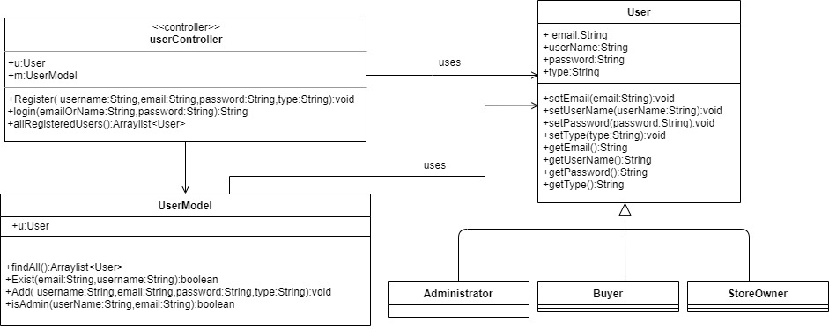

# 

# Sequence diagram design

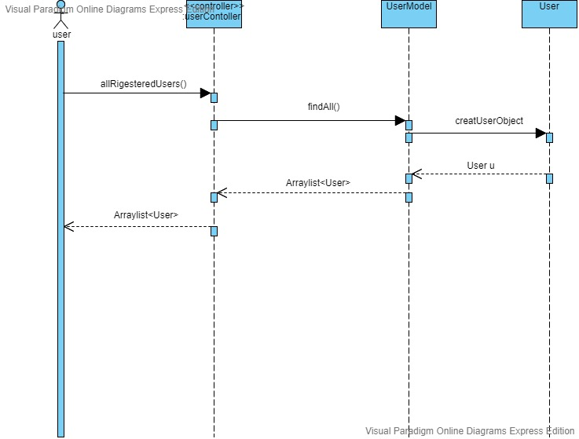

* 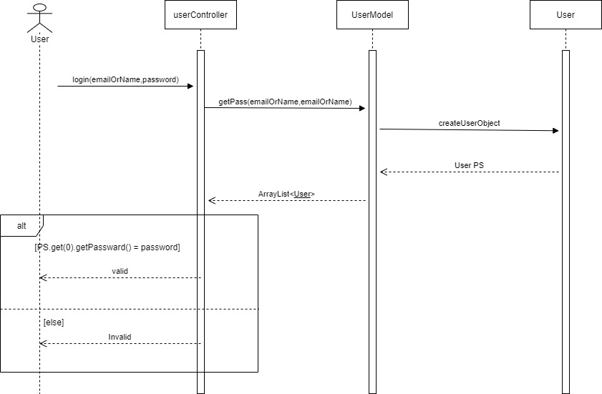

# Github repository link

* **https://github.com/esraa2367/SWE2_PROJECT.git**,